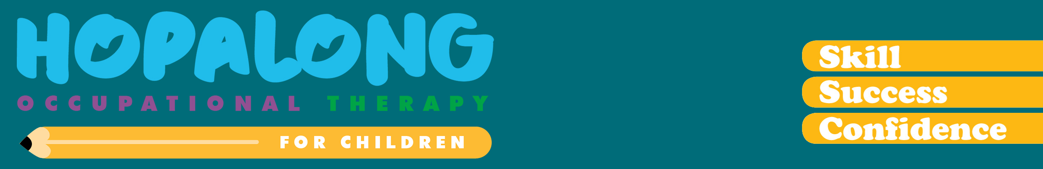

IS YOUR CHILD READY FOR SCHOOL?
HOPALONG SCHOOL READINESS CHECKLIST

FINE MOTOR SKILLS | Yes | Sometimes | Not yet
Threads small beads onto a string
Builds a tower of 10 blocks
Copies block designs of a pyramid and stairs
Can draw shapes
Draws a recognisable person
Able to hold the pencil with a good pencil grip (dynamic tripod) and can control the pencil well
Colours between the lines
Can write or copy own name
Cuts around thick outlines of circles and squares and a curved line
Completes a 12-20 piece puzzle
GROSS MOTOR SKILLS
Runs lightly on toes and around objects
Can walk on heels
Able to balance to walk heel to toe along a line or balance beam (11cm wide)
Stands on one foot 8-10 seconds
Hops forward 10 times on one foot
Able to skip
Catches a small ball using both hands
Throws a small ball accurately from shoulder
Able to run and kick a ball
SOCIAL SKILLS
Able to attend to and remain seated to concentrate on an activity until complete
Eye contact with adults and peers
Listening to and cooperating with adult instructions
Able to emotionally cope with winning and loosing games
SELF CARE SKILLS
Able to take self to the toilet
Able to communicate their needs and request help
Able to open lunch box and recess packets
Able to undo and do up large buttons and fastenings on jumper and pants
Able to put on, take off jumper and pants (for toilet)

Additional speech and language skills are also required for school readiness so please speak with a speech therapist if you are concerned as well as a psychologist for further social, emotional skills.

